**Project 0501-13_OptimusSolutions(SQL)**

**Project Name: Optimus Solutions**

**Output of SQL Business Transactions**

1. What is the total number of transactions by month?

SELECT m.month, COUNT(m.month) AS 'No. of Transactions'

FROM [Optimus.Makes] m

GROUP BY m.month

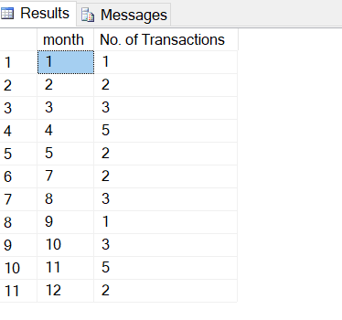

1. What is the total revenue by month?

SELECT m.month, SUM(p.paymentAmount) AS 'Total Revenue'

FROM [Optimus.Makes] m,[Optimus.Payment] p

WHERE m.paymentId=p.paymentId

GROUP BY m.month

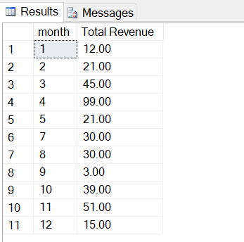

1. How are different locations performing in terms of revenue?

SELECT s.locationId, SUM(p.paymentAmount) AS 'Total Revenue'

FROM [Optimus.Parks] k,[Optimus.Payment] p,[Optimus.Station] s, [Optimus.Makes] m

WHERE s.stationId=k.stationId AND k.vehicleNumber=m.vehicleNumber AND m.paymentId=p.paymentId

GROUP BY s.locationId

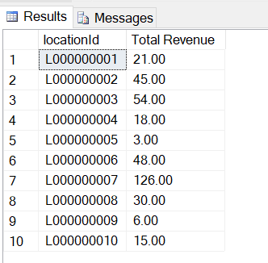

1. How are different locations performing in terms of transactions?

SELECT s.locationId, COUNT(p.paymentAmount) AS 'No. of Transactions'

FROM [Optimus.Parks] k,[Optimus.Payment] p,[Optimus.Station] s, [Optimus.Makes] m

WHERE s.stationId=k.stationId AND k.vehicleNumber=m.vehicleNumber AND m.paymentId=p.paymentId

GROUP BY s.locationId

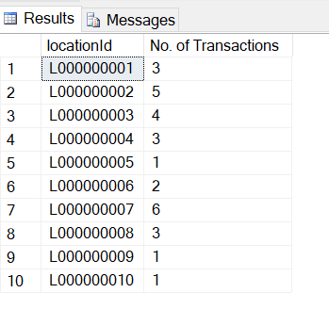

1. Which is the most popular payment mode how much revenue is being generated by each payment mode?

SELECT p.paymentMode, COUNT(p.paymentAmount) AS 'No. of Transactions',

((COUNT(p.paymentAmount)*100)/29) AS 'Percent', SUM(p.paymentAmount) AS 'Total Revenue'

FROM [Optimus.Payment] p

GROUP BY p.paymentMode

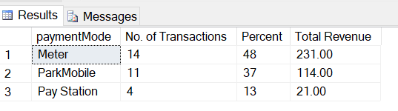

1. What is the revenue distribution amongst drivers with and without a campus permit?

SELECT d.permit, SUM(p.paymentAmount) AS 'Payment Amount'

FROM [Optimus.Payment] p,[Optimus.Driver] d, [Optimus.Makes] m

WHERE m.driverId=d.driverId AND m.paymentId=p.paymentId

GROUP BY d.permit

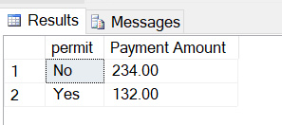

1. What is the number of stations at each location?

SELECT s.locationId, COUNT(s.stationId) AS 'No. of Stations'

FROM [Optimus.Station] s

GROUP BY s.locationId

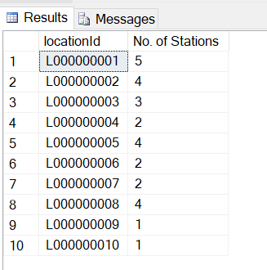

1. How many vehicles have an equipped plugin and how many don't?

SELECT v.equippedPlugin, COUNT(v.equippedPlugin) as 'No. of Drivers'

FROM [Optimus.Vehicle] v

GROUP BY v.equippedPlugin

